Order Of Service

Singing: Psalm 96—CW page 102

Reading: Psalm 46

Opening Hymn: TLH 229

Reading: Acts 3:1-10

Request Hymn: CW Supplement 748

Reading: John 11:17-27

Sermon Hymn: TLH 236

Sermon Text: Song Of Solomon 7:8

Boughs Of The Palm Tree

Prayer

The Apostles’ Creed, TLH page 12

Holy Communion

The Lord's Prayer

The Blessing

Closing Hymn: TLH 234

* * * * * * * * * * *

Bible Study: Lambs: Lightning, Job 37:3-5
Sheep: Romans 2:1-11
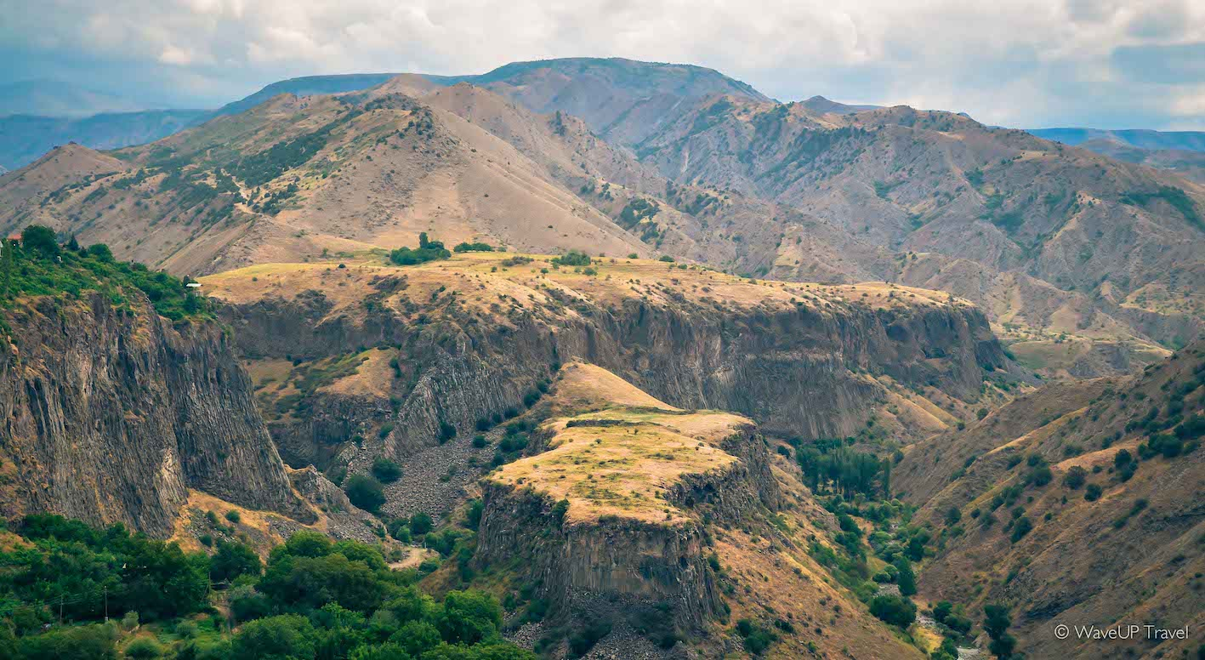

Scenic Mountain Top

Water
Of
Life
16 July 2017

W A T E R O F L I F E

Independent Christian Church—Conservative Lutheran Doctrine

Worship Service: 9:30 a.m. Bible Study: 10:45 a.m.

Larry Cooper, Pastor E-Mail address:
111 N. Ridge Road lcooper@wateroflife.cc
Coon Valley, WI 54623 Web Site:
Phone: (608) 452-2105 www.wateroflife.cc

* * * * * * * * * * * * * * * * * * * * * * * * * * *

Sermon Text: Song Of Solomon 7:8

Boughs Of The Palm Tree

* * * * * * * * * * * * * * * * * * * * * * * * * * *

Song of Solomon 7:8 I said, I will go up to the palm tree, I will take hold of the boughs thereof: now also thy breasts shall be as clusters of the vine, and the smell of thy nose like apples;

Related Readings:

Mark 8:22-26

22 And he cometh to Bethsaida; and they bring a blind man unto him, and besought him to touch him.
23 And he took the blind man by the hand, and led him out of the town; and when he had spit on his eyes, and put his hands upon him, he asked him if he saw ought.
24 And he looked up, and said, I see men as trees, walking.
25 After that he put his hands again upon his eyes, and made him look up: and he was restored, and saw every man clearly.
26 And he sent him away to his house, saying, Neither go into the town, nor tell it to any in the town.

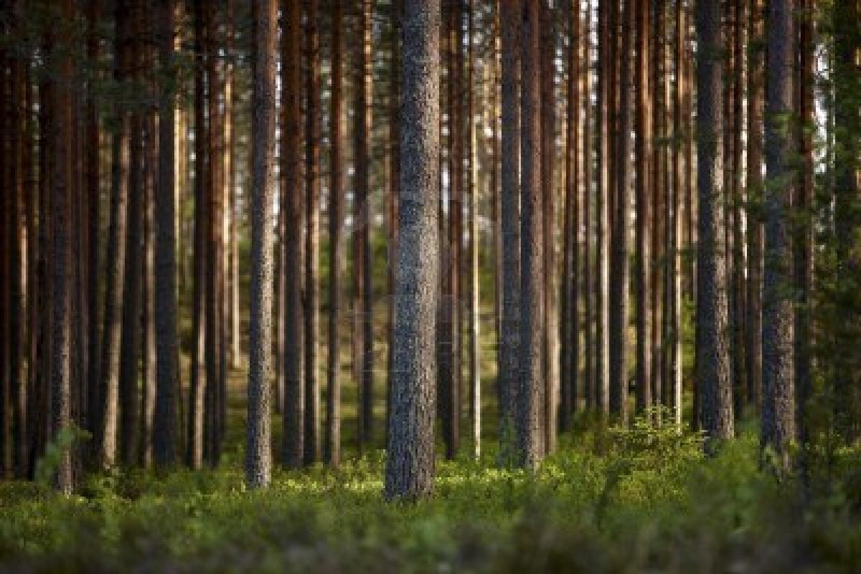

James 2:14-17

14 What doth it profit, my brethren, though a man say he hath faith, and have not works? can faith save him?
15 If a brother or sister be naked, and destitute of daily food,
16 And one of you say unto them, Depart in peace, be ye warmed and filled; notwithstanding ye give them not those things which are needful to the body; what doth it profit?
17 Even so faith, if it hath not works, is dead, being alone.

